

**Functional Design Document for Purchase order latest GRN date.**

***FDD – Purchase order GRN latest revision date for the Invoice.***

Prepared for

**DaxArch Solutions**

Project

**PharmEasy**

Prepared by

Utthej

Contributors

Date: 2023-04-11

Version: 1.0

**Revision and Signoff Sheet**

**FDD Record**

|  |  |  |  |
| --- | --- | --- | --- |
| **Date** | **Author** | **Version** | **Change reference** |
| 2023-04-11 | Utthej | 1.0 |  |
|  |  |  |  |
|  |  |  |  |

**Client Review and Approval**

|  |  |  |  |
| --- | --- | --- | --- |
| **Name** | **Version approved** | **Position** | **Date** |
| Kishore, Jaipal |  |  |  |
|  |  |  |  |
|  |  |  |  |

Table of Contents

Table of Contents 3

1 Introduction 4

Background 4

Purpose 4

Audience / Stakeholders 4

2 Justification 5

Business Requirement 5

Standard Microsoft Dynamics 5

Purpose / Justification for the Modification 5

Open Issues/ Actions 5

3 Modification Description 6

Design Related Assumptions 6

Modifications to Forms / Screens 6

4 Test cases 9

Business Process Flows 9

6 Role based Security Implementation 11

Security Implementation for new objects 11

1. Introduction

## Background

When the purchase order Invoice is created with the latest invoice date.

## Purpose

User required the Invoiced to the latest date of the partially created GRN.

## Audience / Stakeholders

This document is intended for the core team members of project team

* Kishore, Jaipal

1. Justification

## Business Requirement

The functionality is that the multiple receipts which are created by the latest date should be invoiced based on the GRN and even for the payment.

## Standard Microsoft Dynamics

There is no standard functionality available for that specific condition.

## Purpose / Justification for the Modification

This process will help to keep the invoice date based on the GRN

## Open Issues/ Actions

No open Issues/Actions

|  |  |  |  |
| --- | --- | --- | --- |
| **Issue/Action ID** | **Description** | **Assigned to** | **Deadline** |
|  | The functionality is that the multiple receipts which are created by the latest date should be invoiced based on the GRN and even for the payment. |  |  |

1. Modification Description

***Business Process Flows***

## Design Related Assumptions

1. User will navigate to the assigned path.

## Modifications to Forms / Screens

**Procurement and Sourcing> Purchase Orders > All Purchase orders.**

1. The user will create a new purchase order.
2. The product receipt will be done partially.
3. **The dates which are given in the product receipt will have to considered.**
4. **While doing the invoice the latest product receipt date has to considered in the due date filed and be proceeded.**
5. **The vendor payment has to be done accordingly based on the GRN date.**

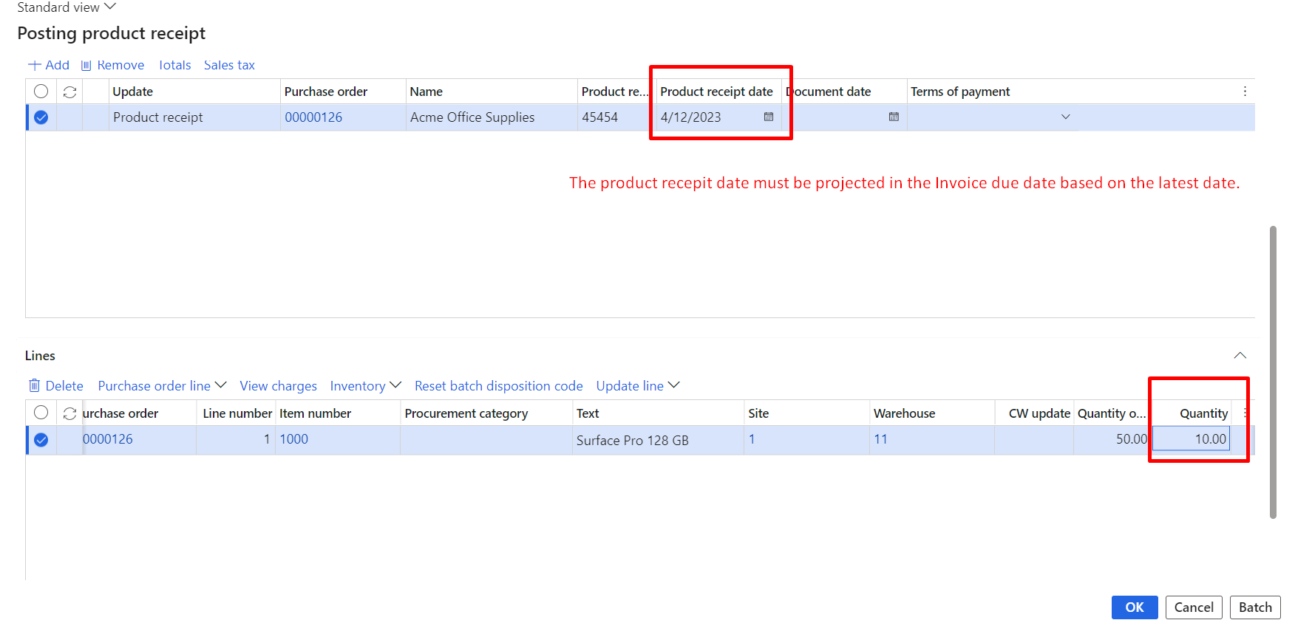

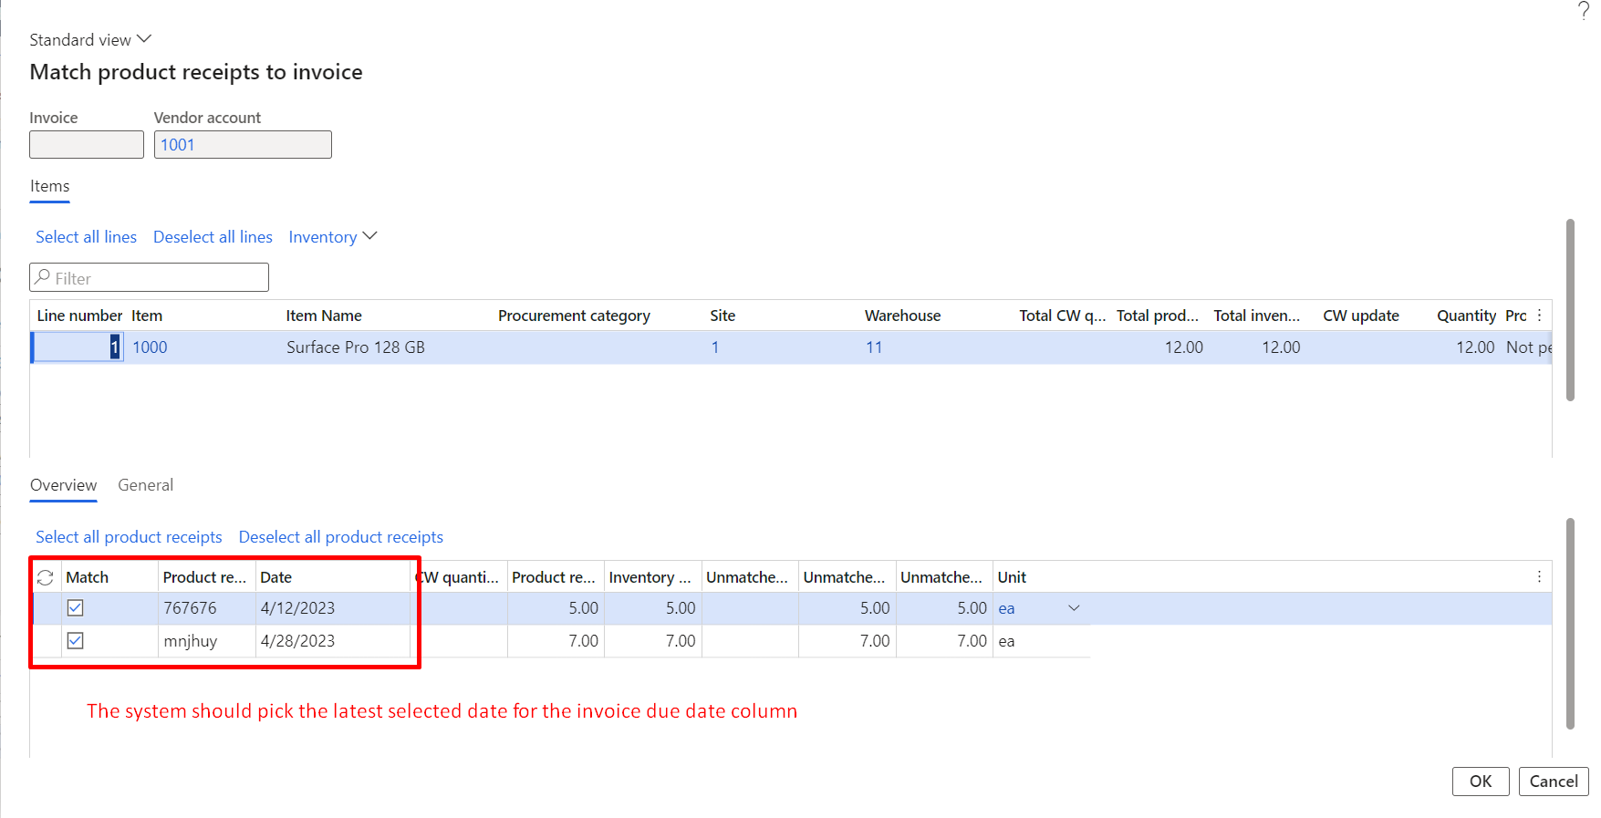

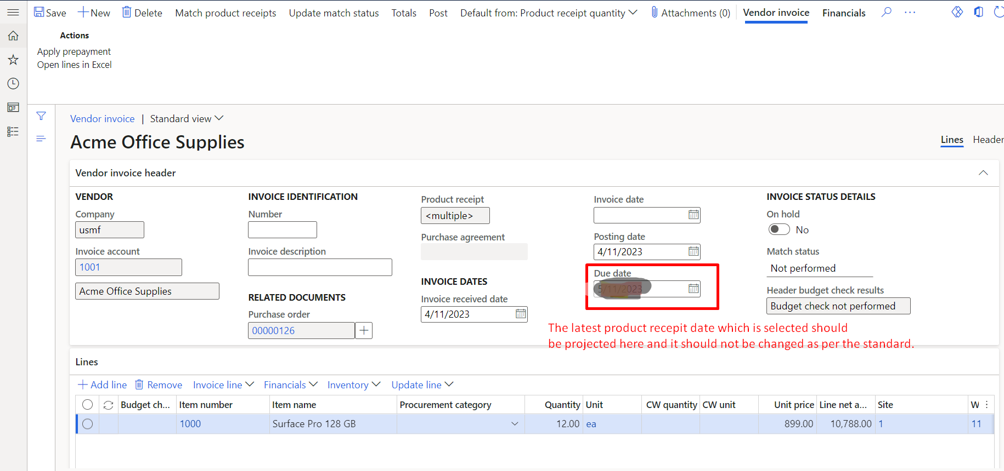

NOTE:

1. If the product recepit latest recepit is cancelled then that particular date should be expilcit and the next highest date should be considered.
2. If the invoiced is done for the partiall quantity. Then the recepit is done for the remaining quantity, the system should consider the latest date of the recepit by neglecting the previously invoiced recepit dates
3. This functionality should work only for the vendors which has the “GRN” parameter button which is enabled for the vendor.
4. A separate parameter enable/disable button should be added for the vendor.
5. If that button is enabled then the developed functionality should work or else it should not effect the standard.

There is an extension.

1. Test cases

## Business Process Flows

# **6 Role based Security Implementation**

## Security Implementation for new objects

**NOTE –**

|  |  |  |  |  |
| --- | --- | --- | --- | --- |
| Object Added (Table/Form/  Report/Class details) | Linked Menu Item to Access the Object | Privilege Linked to the Menu Item | Permissions required if no linked menu item or privilege | Comments on functional requirement on Security for this object |
|  |  |  |  |  |